**Project Design Phase-II**

**Data Flow Diagram & User Stories**

|  |  |
| --- | --- |
| Date | 25 June 2025 |
| Team ID | LTVIP2025TMID30080 |
| Project Name | HealthAI: Intelligent Healthcare Assistant Using IBM Granite |
| Maximum Marks | 4 Marks |

**Data Flow Diagrams:**

A Data Flow Diagram (DFD) is a traditional visual representation of the information flows within a system. A neat and clear DFD can depict the right amount of the system requirement graphically. It shows how data enters and leaves the system, what changes the information, and where data is stored.

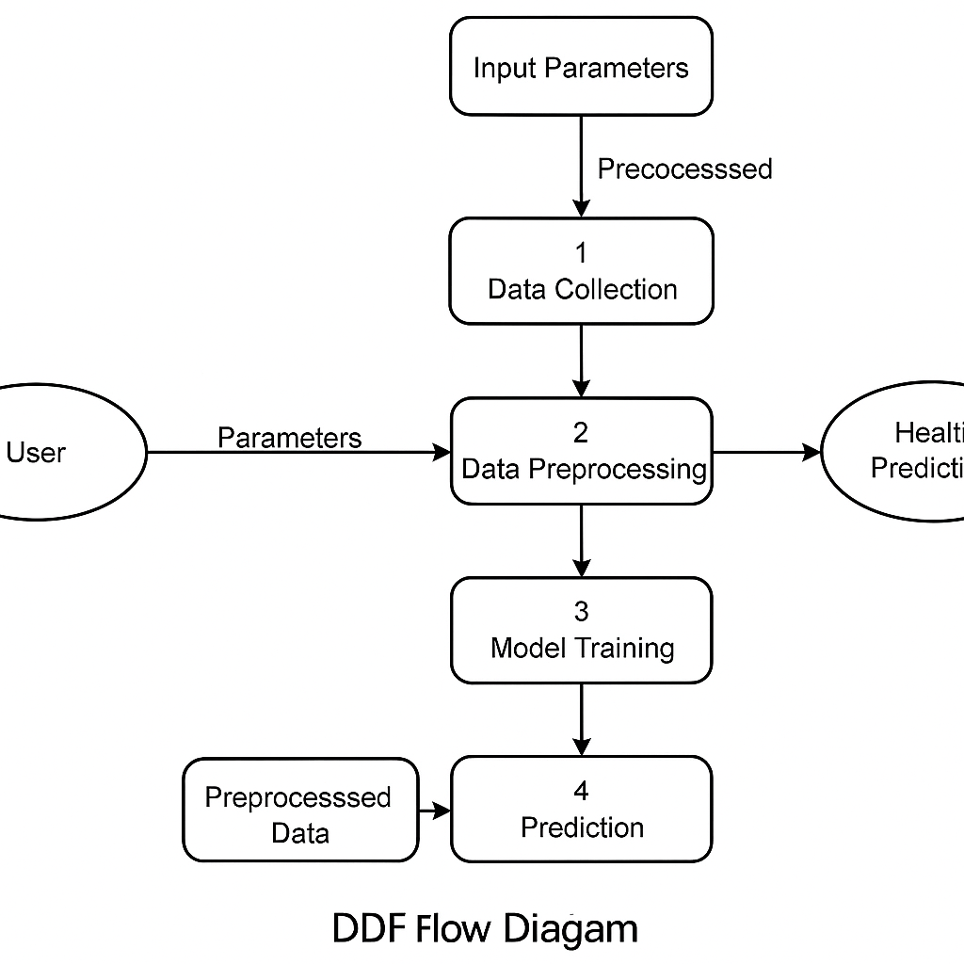

**User Stories**

| **User Type** | **Functional Requirement (Epic)** | **User Story Number** | **User Story / Task** | **Acceptance Criteria** | **Priority** | **Release** |
| --- | --- | --- | --- | --- | --- | --- |
| **Customer (Web/Mobile)** | Symptom Input Interface | USN-1 | As a user, I can enter my symptoms or health metrics into a form | I can enter values like temperature, BP, etc., and submit | High | Sprint-1 |
| **Customer (Web/Mobile)** | Result Display | USN-2 | As a user, I can see a prediction or suggestion based on my input | I can view the output message (e.g., "You might have a fever") | High | Sprint-2 |
| **Customer (Web/Mobile)** | Explanation Module | USN-3 | As a user, I can view an explanation of the result or prediction | A short, readable explanation is shown below the prediction | Medium | Sprint-3 |
| **Customer (Web/Mobile)** | History Tracking | USN-4 | As a user, I can view previous health predictions I made | A table/list of past inputs and predictions is available | Medium | Sprint-3 |
| **Customer (Web/Mobile)** | UI/UX Interface | USN-5 | As a user, I can use a clean and responsive interface | The website/app looks clean and works on both desktop and mobile | High | Sprint-1 |
| **Customer Care Executive** | Feedback Access | USN-6 | As a customer care executive, I can see anonymous user feedback | A feedback dashboard displays user satisfaction data | Low | Sprint-4 |
| **Administrator** | Dataset Update | USN-7 | As an admin, I can upload or update datasets used for training | New data files can be uploaded and reflected in retraining | High | Sprint-2 |
| **Administrator** | Model Monitoring | USN-8 | As an admin, I can monitor the model performance metrics | Metrics like accuracy, precision are shown on the admin dashboard | Medium | Sprint-3 |